Modul 4: Troubleshooting in building systems and building installations: The customer reports a cold room.

Scenario:
A customer bought a second-hand house in the summer. In autumn, the customer notices that one room in the house does not get warm. It is bedroom II (see floor plan below). He has no idea what the problem is and asks you for help.
The customer gives you the following information about his house:
The building is single-storey and was built in the 1980s.
The exterior wall of the house is a double-skin exterior wall with facing brickwork. The interior walls also are made of sand-lime bricks and are plastered. The building does not have a basement.
The windows and the glass door to the terrace have double glazing and a wooden frame.
A gas boiler heats the radiators and provides the hot water supply. The temperature is regulated by two temperature sensors. An outside temperature sensor on the outside wall, which regulates the flow temperature, and a room temperature sensor in the living room. The control unit of the boiler is placed in the living room. The radiators are all fitted with thermostatic valves. The heating control unit with a display is in the living room.

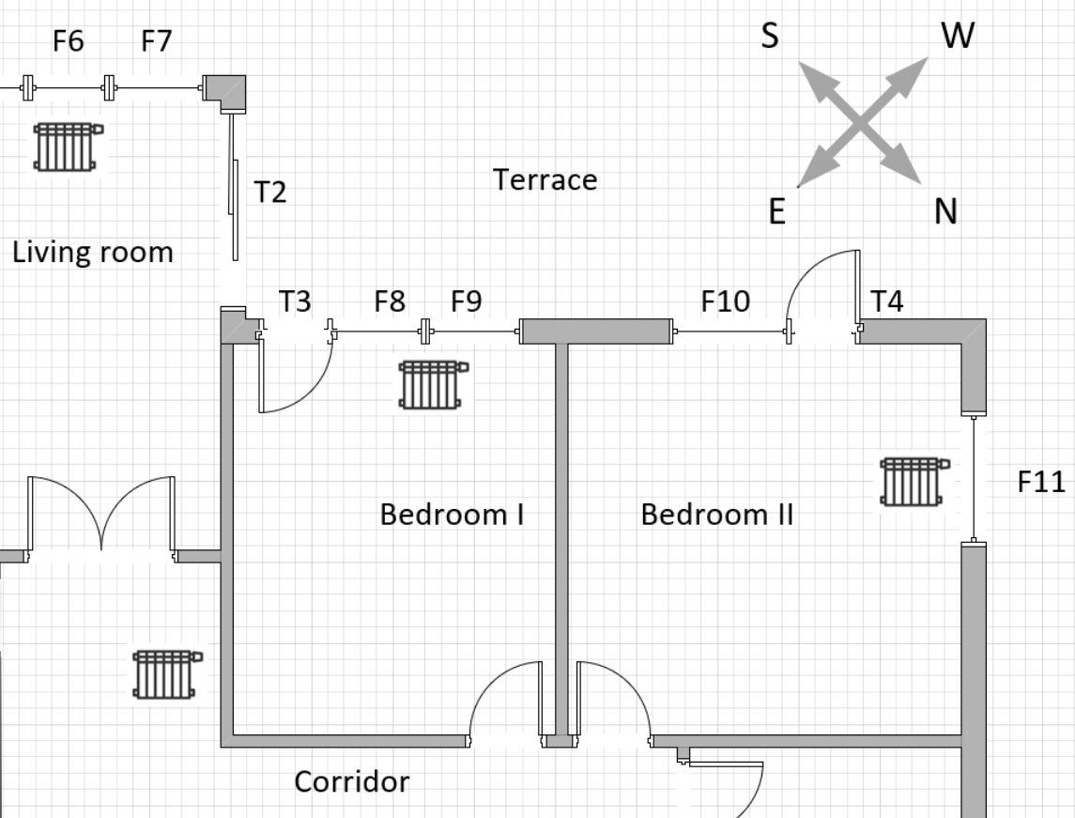 | 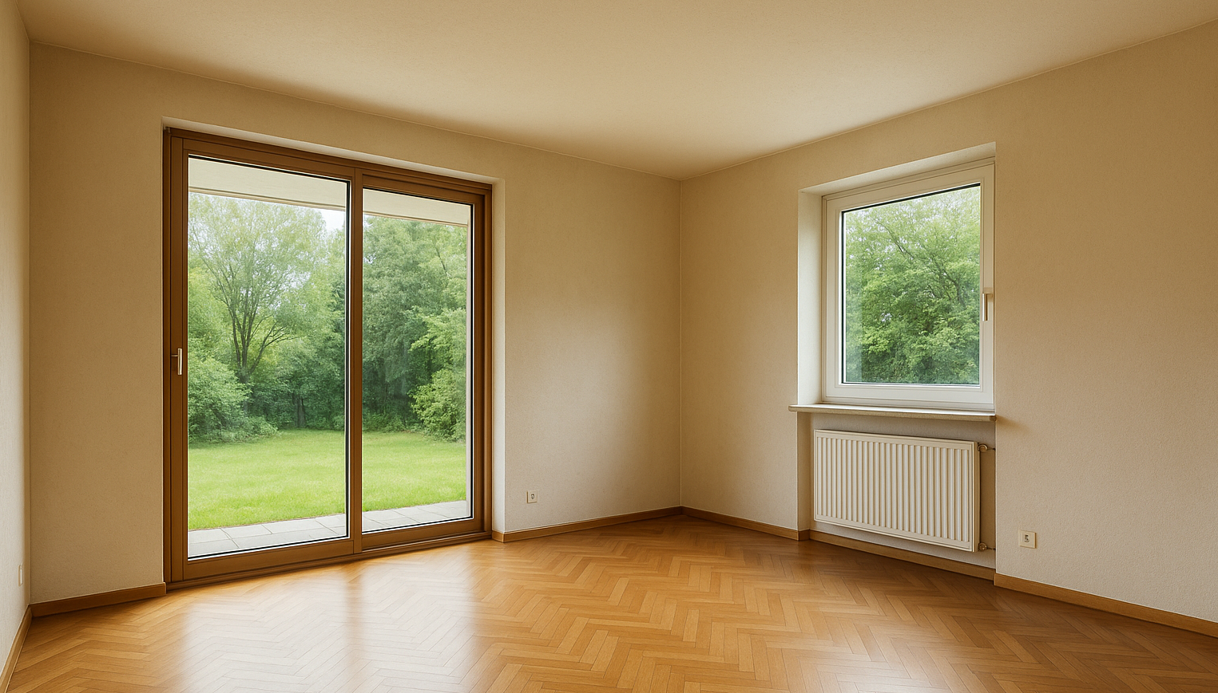
Fig. 1, floor plan  Drawing: M. Sorger | Fig. 2, picture of the cold room  Picture created by ChatGPT

Tasks:
- What could be the reasons for the cold room?
- Collect possible causes for the cold room and present them clearly in the form of a graphic, e.g. as a mind map.
- Discuss the results of the individual working groups.

- How would you proceed to find the cause of the cold room in the customer's building?
- Work out a scheme that can be used to carry out structured troubleshooting and present your scheme graphically, e.g. as a flowchart.
- Also discuss the results of the individual working groups.

Documents and links about heating:
- 02a-Information Heating systems.docx
- 02b-tasks-Heatingsystems-blanc.docx
- https://www.youtube.com/watch?v=F8Tpwxgtb4A

Documents and links about the building envelope:
- 03-Information sheet_Building wall_cold room_eng.docx

