Modul 4: Troubleshooting in building systems and building installations: The customer reports a cold room.

Information Heating Systems:
This graphic shows the structure of a simple heating system
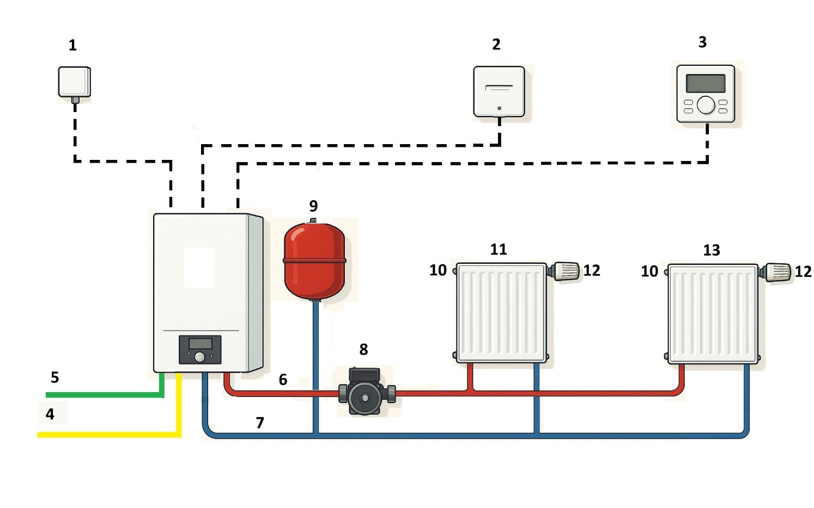
Graphic: ChatGPT

Information Heating Systems, Part II
The following table shows an overview of the many different heating systems, categorized by primary energy source.

Primary energy source / fuel | Typ of heating | Function | Heat transport and heat transfer in the building | Temperature control
Oil | Oil boiler | Heating water through the combustion of oil | Heat transport through water  Heat dissipation mainly via convection through:  - Radiators  - Heating coils (underfloor heating) | Boiler: Weather-dependent boiler flow temperature (central for each heating circuit)  - Radiators: Thermostate valves  - Underfloor heating: temperature-dependent regulation of the flow rate per room or zone using electrically operated valves
Gas | Gas boiler | Heating water through the combustion of oil and utilization of the thermal energy of the burner exhaust gas
Wood | Wood pellets | Heating water through the combustion of wood pellets, wood chips or firewood
Wood | Wood chips
Wood | Firewood
 | Stove | Burning wood logs | Heat dissipation through heat radiation
Electricity | Night storage heaters  Electric radiant heater  Electric panel heating: wall heating or underfloor heating | Heat generation through heating rods or heating coils  Heating wires in the wall or wallpaper or in the floor | Heat transport through air  Heat dissipation through heat radiation | by switching the heating elements or the heating coils on and off (2-point control)
Solar Energy | Collectors (flat-plate collector or tube collector) | Heating of a liquid by the radiant energy of the sun in the solar collectors. The liquid transfers the heat energy to a hot water tank in a heat exchanger, which feeds the heating water circuit. | Heat transport through water  Heat dissipation: mainly via convection through  - Radiators  - Heating coils (underfloor heating) | - hot water tank: 2-point control by solar thermal controller  - Radiators: thermostatic valves  - Underfloor heating: temperature-dependent control Temperature of the flow rate per room or zone using electrically operated valves.
Ambient heat (earth, air, water) | Heat pump | Extraction of heat outside and release inside the house.  Physical principle: Joule-Thomson effect  Cooling is also possible by reversing the process
Ambient heat of the air | Special case air-to-air heat pump:  Split air-conditioning system | Works like a heat pump:  Cooling and heating possible | Heat transport through air | by switching the split air conditioning system on and off using thermostats (2-point control)
Different energy sources possible | Combined heat and power plant | Heat generation:  Utilization of waste heat from a combustion engine or a fuel cell.  Power generation:  By fuel cell or generator driven by the engine. | Heat transport through water  Heat dissipation: mainly via convection through  - Radiators  - Heating coils (underfloor heating) | Flow temperature is specified by the provider and cannot be influenced  - Radiators: thermostatic valves  Underfloor heating: temperature-dependent control Temperature of the flow rate per room or zone using electrically operated valves.
Different energy sources possible | District heating | Use of a fossil thermal power plant, a fossil power plant to generate electricity or a CHP unit.  The thermal energy is not generated at the user's location, but is routed to the buildings via a network of district heating pipes. |  | Flow temperature is specified by the provider and cannot be influenced  Temperature control of the radiators:  Thermostatic valves  Underfloor heating: temperature-dependent regulation of the flow rate per room or zone using electrically operated valves.

