Modul 4: Troubleshooting in building systems and building installations: The customer reports a cold room.

Components of a heating system, task:
- Name the components shown in positions 1 to 13 in the heating diagram.
- Briefly describe the function of the components.
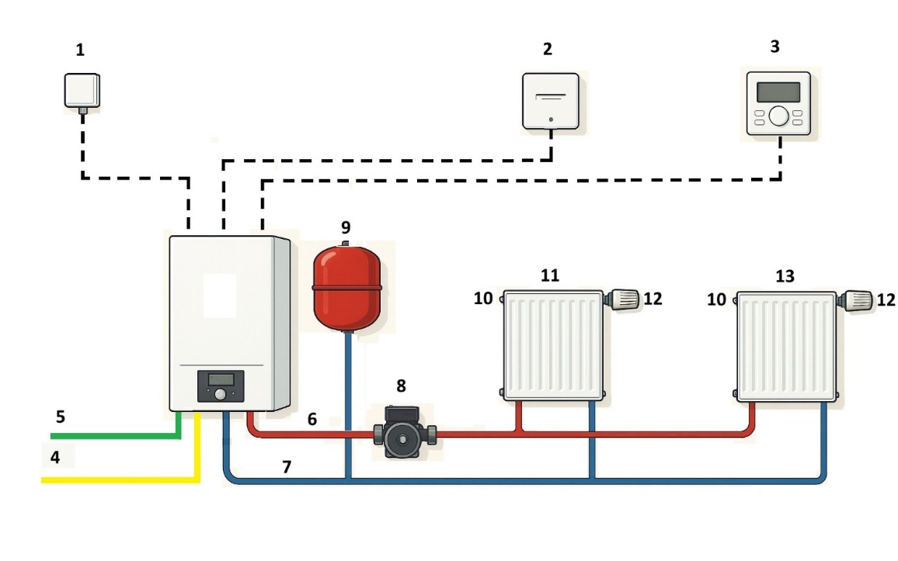
Pos. | Name | Task
1 | Outdoor sensor | Measurement of the outside temperature
2 | Room sensor | Measurement of the room temperature
3 | Romm controller | Combination controller/operating unit; regulates the flow temperature of the heat generator depending on the outdoor and room sensor
4 | Gas connection heat generator | Fuel supply for the heat generator
5 | Power connection  Heat generator | Supply of electrical energy for the heat generator
6 | Pipe flow | Pipes for transporting the hot water to the radiators
7 | Return flow | Pipes for transporting the cold water back to the heat generator
8 | Heating pump | Ensures the transport of water in the heating circuit
9 | Membrane  expansion vessel | Ausgleich temperaturbedingter Volumenschwankungen im Heizungskreislauf
10 | Vent valve  Radiator | Equalisation of temperature-related volume fluctuations in the heating circuit
11 | Radiator | Release of thermal energy to the room air mainly by convection
12 | Thermostat valve | Regulates the volume flow of hot water through the radiator and thus the amount of heat energy emitted.
13 | Radiator | Release of thermal energy to the room air mainly by convection

