Modul 4: Troubleshooting in building systems and building installations: The customer reports a cold room.

Components of a heating system, task:
- Name the components shown in positions 1 to 13 in the heating diagram.
- Briefly describe the function of the components.
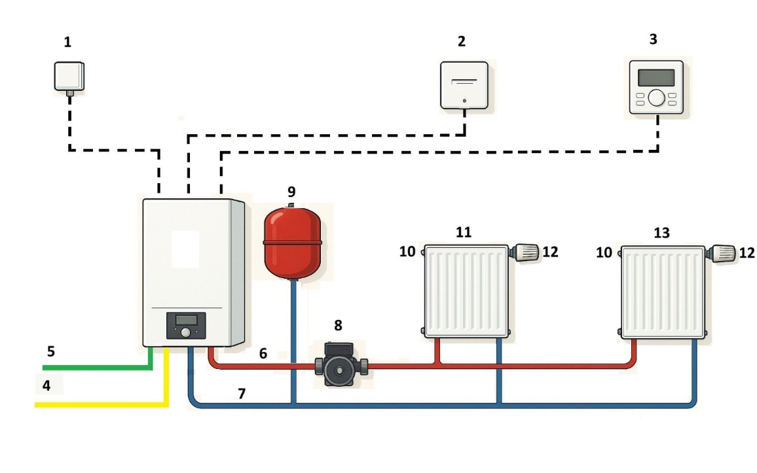
Pos. | Name | Task
1
2
3
4
5
6
7
8
9
10
11
12
13

